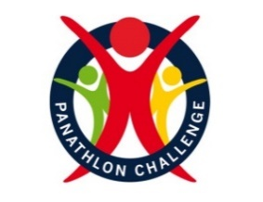

Special Schools Summer Panathlon
Murray Movement | Tennis
Javelin | Funfair Football
Direct Hit | Football
Parachute | Shuttle Run

Thank you for electing to take part in the summer multi-skills. This pack contains: rules, results templates for internal use, video clips and monitoring forms.

Summer multi-skills enables competitors can take part in a series of activities across several weeks or sessions. Individual schools can select their own activities based upon their own judgements regarding facilities, zones, teaching bubbles, equipment, time allocated, current national guidelines, school policies and risk assessments.

General Guidelines
- Activities can be run by the class teacher or with the help of additional leaders/helpers.
- Teachers will need to select their own team ‘micro bubble’ sizes based upon their risk assessments.
- Each ‘micro bubble/team’ will move to each activity via set ‘zones’ in accordance with school policy.
- Schools can select activities from the menu and decide upon their own length of time to complete the activities i.e. 5 minutes per activity or a set number of goes (based on individuals or equal size teams).
- Schools can choose to record team/ bubble or individual scores and opt to produce their own school rankings for internal use.

Equipment Guidelines
- Where possible, one piece of equipment each, rather than shared.
- Ensure that equipment is safe after each activity to stop slips and trips when rotating to each zone.

To receive certificates, send a completed monitoring form to entries@panathlon.com

Murrray Movement
Video Link: https://youtu.be/GRjq11aQ4t0

Equipment
Bean bag (ball, or rolled up socks), tennis racket (or badminton), 17 x cones.
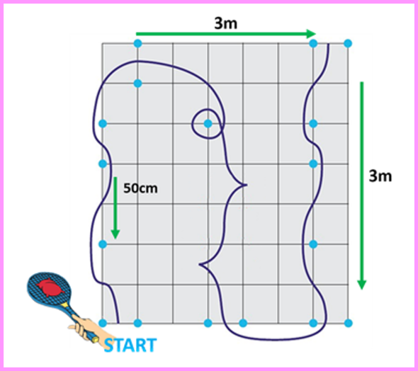
Set-up

Cones are set out 50cm apart (measured from end of cone)
with chalk or floor markings showing the direction. 3.5m x 3.5m

Aim: ‘Complete a slalom course around the cones’, with the bean bag balanced on a tennis racket.
Team members take it in turns. Activity can be varied using a football or hockey sticks to dribble.

Scoring

- Team: Number of completed slaloms, in 5 minutes
- Individual: 2 attempts. Add times together.

Adaptations

- VI: Competitors can follow a guide.
- HI: Visual cues can be given to start the slalom, eg, lower an arm to start.
- Wheelchair users: Self-propel on a wider course (1m at each cone) or be pushed.
Can carry the beanbag without a racket, if required.

Javelin
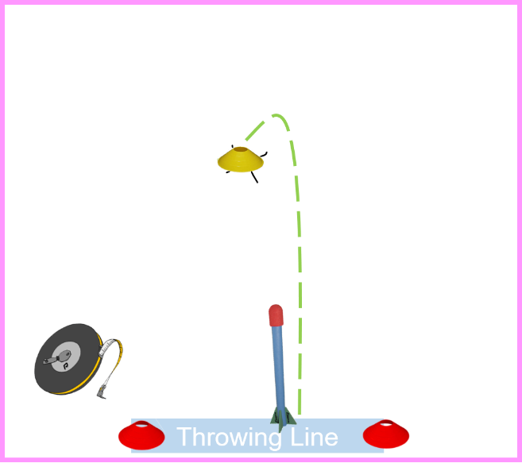
Equipment: Foam Javelin, 3 cones

Set-up
- 2 x cones to form the throw line.
- 1 x cones per competitor for measuring,

Aim
Each player has 3 attempts to throw a javelin as far as they can with the aim of trying to beat each throw.
- Allocate each player a small, different coloured cone.
- After each throw ask the teacher/helper to place the players cone on the exact area that the javelin first hits the ground.
- Move the cone forwards each time that the player throws further. (do not move the cone backwards if the throw is shorter on any attempt)
Scoring
After the third throw measure the exact distance with the tape measure for an accurate score.
Record the best distance thrown for each player then allow them to start again and repeat the three throws.
- Team score: Add the top two players ‘best’ distances together. ( e.g., 15m + 20m)
- Individual score: Record the ‘best’ throw. (e.g., 14m)

Adaptations
- VI - leader/helper can clap in direction of cones.
- Wheelchair users – can do a seated throw.

.
Direct Hit
Video clip - https://youtu.be/tUgXuDH47kg
Equipment
1 ball per person (bean bag), set of stumps (skittles/cardboard tubes or equivalent) 1 x cone
Set-up
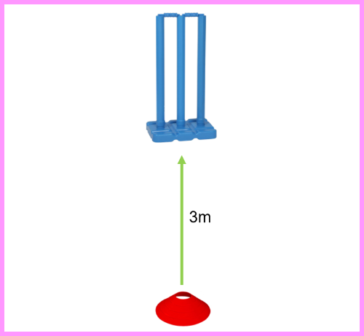
- Place one set of stumps/skittles 3 metres from a throw line.
Aim ‘Hit the stumps’
- A continuous team relay that gets more difficult.’ (aim at the stumps for points - take stumps away!)
- 1st round: The first competitor stands at the cone and rolls/underarm throws the ball towards the stumps, collect their ball, join the end of the queue. The next competitor takes their turn until everyone has had one attempt.
- 2nd round: Take the stump away leaving two. (Select a designated person to remove stumps)
- 3rd round: Take one stump away leaving one.
- NOTE: The next competitor does not throw until the previous player has collected their ball & rejoined the queue.
- After 3rd round, re-start the game for a second attempt to beat the score.

Scoring
- 1st round: 1 point, if any of the 3 stumps are hit.
- 2nd round: 2 points, if any of the 2 stumps are hit. (If unable to take away stumps-aim for outside stumps)
- 3rd round: 3 points, if the final stump is hit. (If unable to take away stumps-aim for middle stump)
- No points if the ball hits the base only, rather than a stump.
Team Add every score to give the team/bubble total, within 5 minutes if timing or two full rounds.

Individual Two full rounds (3/2/1 stump) – add scores together (1+2+3+0+0+3=9)
Adaptations
- VI: Leader/helper can clap near the stumps.
- Bell balls can create audio cue.
- Wheelchair users take their shots closer or use ramps to propel the ball.
Parachute Popcorn

Equipment
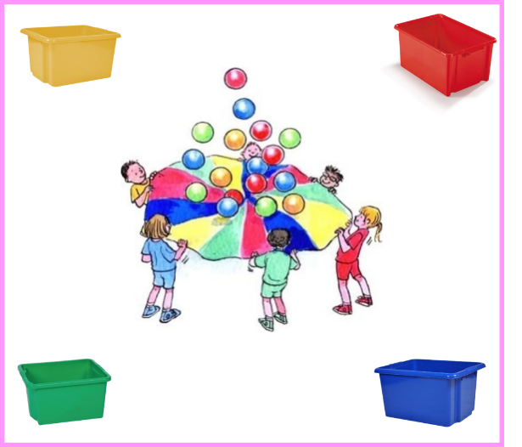
- 1 x Parachute, six blue, red, yellow and green playballs – 24 in total
- Box or bucket for ball collection
- Stopwatch

Set-up
- Competitors stand spread out around the outside of the parachute lifting the parachute up which contain six blue, red, yellow and green playballs – 24 in total
Aim ‘ Collect the balls and place in the containers.’
- Shake the balls so that they fly off the parachute,
- The helper will then then say ‘GO’ which starts the stopwatch.
- Players start collect the balls ensuring that they are placed in the corresponding, coloured container.
- The stopwatch will stop when all the balls have been collected in the correct container.
- Competitors are only allowed to pick up one ball at a time.
Scoring
- Team The time is recorded when 24 balls are placed in the correct coloured collectors e.g. 6 red/6 blue/6 yellow/6 green. Teams may have two attempts, to achieve their best time. The best time is then recorded.
- Individual With helpers holding the parachute- time the individual collecting 6 balls, then repeat for a second attempt.
Adaptations
- VI: Can follow a leader or use a guide as assistance.
- HI: A visual cue can be given by the leader to start, as well as audio. eg, lower an arm to start.
- Wheelchair users: Can be pushed.
- PD & LD with balance difficulties: can have support from an adult. Children can walk from number to number.

Rally Tennis

Video Clip https://youtu.be/FZ4dT48kZ2o

Equipment
Ball, tennis racket or equivalent per child, tape. (rackets to be wiped after each go)

Set-up
Mark out the court area with tape. Use half a badminton court in width or (2m width) length 6 m (no net)

Aim ‘ Count the rally’
Two competitors stand and aim to push/roll the ball in a continuous rally on a small court between two cones. The ball must go past the minimum hit line (2m)
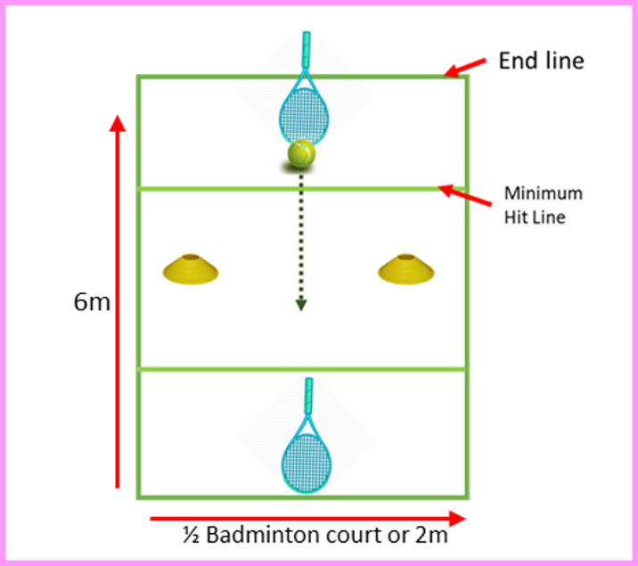
The rally ends when:
- The ball lifts from the floor
- The ball goes past the end line
- The ball hits a player’s body, including hand
- The ball does not pass between the cones
- The ball is hit inside the minimum hit line
- The ball stops within the minimum hit line

Rotate each pair after each rally ends (Max rally 30 secs)

Scoring

Team The highest rally for the team is recorded

Individual Highest score with a partner

Adaptations
- Bell balls can aid VI players.
- Wheelchair users can use their chair to stop the ball, this does not affect rally count (side on using the big wheel, taking extra care when pushing from backwards to forwards),
- Wheelchair users could also use a cricket bat/hockey stick if unable to reach to the floor, but ball must still stay along floor.

Funfair

Video Link: https://youtu.be/hqpXXUBzB34

Equipment:
- 5 x Footballs (1 Football & 4 x Balls - beach balls, plastic balls)
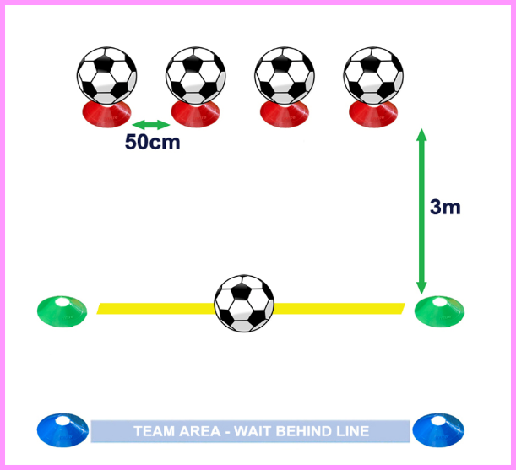
- Cones
- Tape (or Cones, Floor lines)

Set up:
- Place four space marker cones in a straight line spaced 50cm apart. Place a ball on each.
- Mark a kicking line, 3m parallel to the cones.

Aim: “Knock the Balls off cones.”
- 1 player enters the playing area.
- Players have 4 passes/kicks each.
- The football needs to be kicked from behind the line.
- Involve a helper to remove the knocked over balls from the playing area and help retrieve the ball.
- Note that a ball cannot be knocked off when rebounding from a wall.
- Continuous relay for 5 minutes.

Scoring:
- 1 point for each ball knocked off.
- If all 4 balls are knocked off within one players turn - award +1 bonus point.
- Maximum 5 points gained per turn.

Team: Total number of points from 5 minutes play.
Individual: Three attempts. Add all three scores together.

Adaptations:
- Visually Impaired: A bell ball will create an audio cue and leaders or teachers clapping in the direction of the target area will aid direction for players.
- Hearing Impaired: A paddle will give a visual cue to signal a players turn.
- Wheelchair users: Can kick or bowl the ball towards the targets, ramps can be used to propel the ball.

Football: Dribbling Weave

Video Link: https://youtu.be/tOynyGXsAHo

Equipment:
- 1 x Football
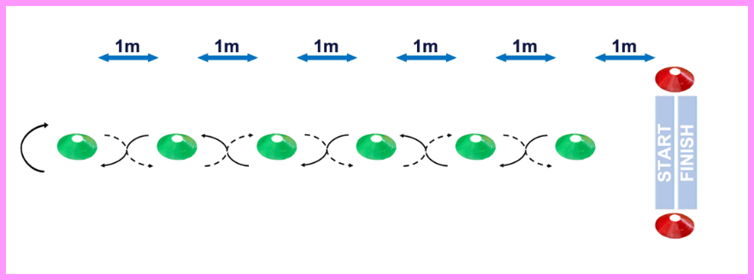
- 6 x Cones, to weave around.
- 2 x Further Cones, for start/finish (Tape, Chalk, Grass Marking Paint, Floor Line)

Set up
- Start/Finish line is 1m from the first cone. Place 6 cones 1m apart in a straight line.

Aim “Dribble a football between cones, there & back”.
- 1 player at a time.
- Start and finish in the same place.
- Ask the player to stop the ball on the Start Line for the next player (rather than pass).
- Continuous relay for 5 minutes.

Scoring
- 2 points are scored for successfully weaving ‘up’ between all the cones and 2 points are scored for successfully weaving ‘down’ between all the cones, back to the start line.
- 1 point is awarded for weaving ‘up’ or ‘down’ if any weaves are missed or cones are hit by the ball.
- A maximum of 4 points and minimum of 2 points can be scored in any players attempt.

Team Total number of points scored, within 5 minutes or (3 goes each based on equal team sizes)

Individual Player has 3 goes (there and back) and adds all their scores together. Each go can be taken with a rest in between, if required.

Adaptations
- To simplify take away every other cone.
- VI: A bell ball will create an audio cue to aid direction of the ball. Leader/helper can clap in direction of cones.
- HI: A paddle will give a visual cue to signal when to start.
- Wheelchair users: Can carry the ball on their lap around the course.

Shuttle Run

Equipment

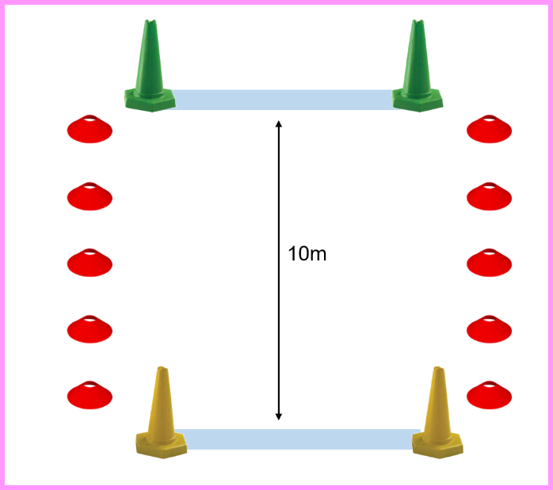
- 4 x Large Cones
- Stopwatch
- Whistle or Start Flag
- Cones to mark sides of running area.

Set-up
- Set out 10m course with cones either end.

Aim ‘ timed sprint over 10m.’
- Four lengths to complete the time.

Scoring

Team Add the team times together (Based on 5 in a team)

Individual Player has two attempts to beat the time. Each go can be taken with a rest in between, if required.

Adaptations
- Distance (can be reduced/ extended depending on age or ability)
- VI: Leader/helper can clap in direction of cones or work as a guide
- HI: A paddle will give a visual cue to signal when to start.

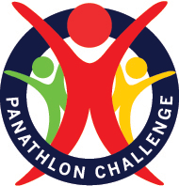
EXAMPLE - Summer Team Results
Team Results  Timed event or number of goes added. | Murray Movement  (Number complete) | Javelin  (Add scores) | Direct Hit  (Add scores) | Parachute  (Number complete) | Tennis  (Highest Rally) | Funfair  (Add scores) | Football  (Add scores) | Shuttle Run  (Add times) | Overall Points  Total  Lowest number of ‘Overall Points’ wins | Finishing  Position
Team  Yellow Class | 8 | 12m | 6 + 6= 12 | 8 | 10 | 30 | 16 | 2.30min
Position/Overall Points | 2nd | 4th | 4th | 2nd | 3rd | 1st | 3rd | 1st | 20pts | 2nd
Team  Red Class | 10 | 24m | 12 + 12= 24 | 10 | 5 | 25 | 12 | 3.20min
Position/Overall Points | 1st | 1st | 1st | 1st | 4th | 2nd | 4th | 3rd | 17pts | 1st
Team  Blue Class | 6 | 18m | 9+9=18 | 6 | 14 | 20 | 20 | 2.40min
Position/Overall Points | 3rd | 3rd | 3rd | 3rd | 2nd | 3rd | 2nd | 2nd | 21pts | 3rd
Team  Green Class | 4 | 21m | 12+9=21 | 4 | 20 | 15 | 24 | 3.45min
Position/Overall Points | 4th | 2nd | 2nd | 4th | 1st | 4th | 1st | 4th | 22pts | 4th
EXAMPLE - Summer Individual Results
Individual Results | Murray Movement  (Add times) | Javelin  (Add scores) | Direct Hit  (Highest scores) | Parachute  (Times) | Tennis  (Highest Rally) | Funfair  (Add scores) | Football  (Add scores) | Shuttle Run  (Fastest time) | Overall Points  Total  Lowest number of ‘Overall Points’ wins | Finishing  Position
Name | 32 sec | 12m | 6 + 6= 12 | 1.55 mins | 10 | 30 | 9 | 45 sec
Position/Overall Points | 2nd | 4th | 4th | 2nd | 3rd | 1st | 3rd | 1st | 20pts | 2nd
Name | 30 sec | 24m | 12 + 12= 24 | 1.45 mins | 5 | 25 | 8 | 52 sec
Position/Overall Points | 1st | 1st | 1st | 1st | 4th | 2nd | 4th | 3rd | 17pts | 1st
Name | 40 sec | 18m | 9+9=18 | 2.15 mins | 14 | 20 | 10 | 50 sec
Position/Overall Points | 3rd | 3rd | 3rd | 3rd | 2nd | 3rd | 2nd | 2nd | 21pts | 3rd
Name | 55 sec | 21m | 12+9=21 | 2.30mins | 20 | 15 | 11 | 1.20 mins
Position/Overall Points | 4th | 2nd | 2nd | 4th | 1st | 4th | 1st | 4th | 22pts | 4th
Result Sheet- For Team or Individual
Team/Individual Name | Murray Movement  (Number complete or times) | Javelin  (Add scores) | Direct Hit  (Highest scores) | Parachute  (Times/number complete) | Tennis  (Highest Rally) | Funfair  (Add scores) | Football  (Add scores) | Shuttle Run  (Time/add times) | Overall Points  Total  Lowest number of ‘Overall Points’ wins | Finishing  Position
Team/Individual Name

Position/Overall Points
Team/Individual Name
Position/Overall Points
Team/Individual Name

Position/Overall Points
Team/Individual Name
Position/Overall Points
Panathlon Monitoring Form: Summer Games (Special Schools)

School Name:  County/Borough: |  |  |  | Disability – Number disabilities that apply  Key below |  |  |  |  |  |  |  | Ethnic Code  Key below
Total Number | Year Group | Leaders  (Age & No) | Gender  M / F | PI | HI | VI | SLD | MLD | AS | ManW/C | Pow  W/C | Code  e.g. 4 students x 1  2 students x 4
Pre-season

Game Day

KEY
Disability Physical Impairment (PI), Hearing Impairment (HI), Visual Impairment (VI), Severe Learning Disability (SLD)
Mild Learning Disability (MLD), Autistic Spectrum (AS), Manual Wheelchair (Man W/C), Power Chair (Pow W/C)
Ethnicity For each athlete, enter the code in the box provided (i.e. 1).
 |  | Ethnicity Code
1 = White | 2 = Mixed | 3 = Asian or  Asian British | 4 = Black or  Black British | 5 = Chinese or  Other Ethnicity

