School: Watton Junior Academy Date: 16/09/2021
Following my recent visit to your school to deliver Gymnastics Staff CPD, we discussed and looked at a number of aspects of resourcing for the delivery of high-quality curricular gymnastics. Please find below details of the suggestions and recommendations for the school which we discussed and may be of value and intertest to you to progress provision. Whilst funding is available, I would strongly urge you to invest to sustain high-quality teaching and learning in and through gymnastics.
Safety Recommendations:
The wall bars fix in place by a bolt and ladder brace system with bolts being secured through holes in the floor. Many of these are filled with dirt accumulated over time and as such no longer provide an adequate depth in which the bolt can be secured. These simply require cleaning out to allow the bolts to fully engage. A combination of a vacuum and a screwdriver to ‘dig’ out the detritus is usually sufficient or if more stubborn a drill to break-up and then reverse it to lift out the material. This will allow bolts to engage fully.
Level: Strongly advise to do this before they are used.

Apparatus Recommendations & Suggestions:
Comment:
The school has both wall-bars and a set of ropes. Staff were concerned that they had been ‘told’ that they could not use ropes but couldn’t remember why or by whom. We looked at their use and a thorough visual / practical test was made before venturing onto them. No reason could be seen for not using.
Agreed action: School to check on last safety inspection paperwork (perhaps Sportsafe UK) to check that there was nothing listed regarding safety of ropes (plus any other apparatus).
There is very little portable apparatus with which to create an interesting and stimulating layout which both engages and challenges the pupils. This means that apparatus work potentially will be based on two pieces – Ropes and Wall Bar with a variety of ‘bench activities’ thus limiting progress and achievement. To rectify this, I suggest the following:
Nesting Trestle Tables.
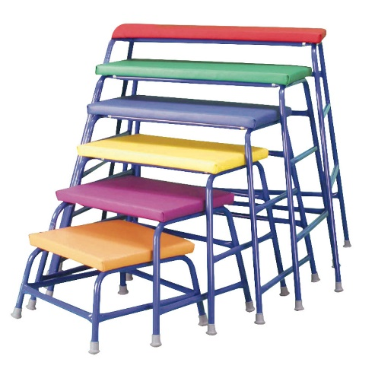
- These could be a full set or you could choose to have perhaps two of the higher trestles and not have the very low ones as these are aimed at through primaries. Most companies will sell a set and / or trestles of various heights separately.
- These will allow you to add linking apparatus as well as create additional apparatus for pupils to use to climb, balance, jump, turn etc. from creating a greater variety of ‘platforms’ from which to progress and challenge their work.

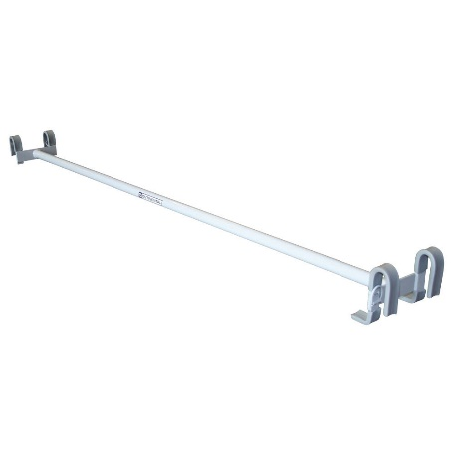
Linking Pole:
This will allow a pole to be fixed between the Wall-Bar pull out section and the grey ladder fixing on the wall. This allows pupils to experience rotation around the pole (forward and backward) in a safe way and add additional movement opportunities. The bar/pole can also be fixed to the Trestles if required.
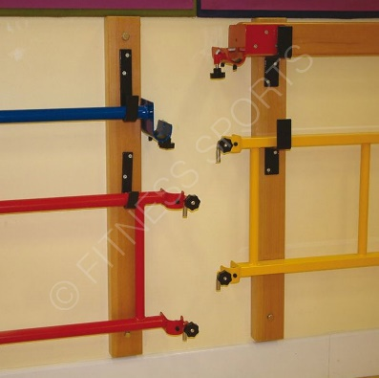
Make sure that the Pole is compatible with Wall-bars by discussing this with the safety inspection company – we believe this to be Sportsafe UK. They may well be able to supply too. Will be a little more expensive this way but not much and you will get the correct one.
Suggestion: Ask them for the Wall Hooks so that the linking pole and ladder that you already have can be better and more safely stored via hooks on the wall underneath the display boards as you enter the hall.

Balance Beam:
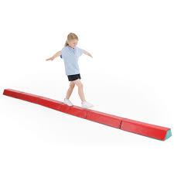
To save having to use benches the new soft, foam balance beams offer a really good alternative which is safe to use, easily moved and stored. These would allow pupils to develop their balance which we know from research can be linked to academic progress too. They are not expensive and can also be used in a Gymnastic Club should one be set up. They can also form an effective linking apparatus to promote travel around the hall and link between pieces of apparatus. They are suitable for all ages across the Junior School age range.
Mats:
There is nothing wrong with the Mats that the school has but they are the Infant size, lighter mats at 3’ x 4’. I would recommend purchasing an additional class set (15 – 30 pupils, 2 per mat) of the larger mats to allow full movement of pupils in safety over the surface. Staff commented also that pupils often roll-off the small mats and with the size of Key Stage 2 pupils I would recommend the 6’ x 4’ Mats
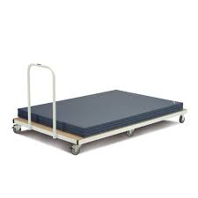
Mat Trolley:
I have not seen one of these trolleys for a long time. They are functional but have to be used correctly to avoid potential injury to both staff and pupils alike. Any vertical mat trolley also necessitates that the teacher has to help the pupils to put the mats back, forcing the teacher into a space and task that can reduce their effective ability to supervise and monitor the rest of the class.
I therefore recommend a Flat-bed Mat Trolley to allow pupils to simply walk over and lower the mats in place therefore negating the teacher needing to assist. They also reduce the mat bending as they are flat rather than standing on their edge.

